P1d Part 1: Cooking with Waves

Learning Objectives:
1. about bodies that give out infra red radiation
2. about the heating effects of microwaves
3. how frequency affects energy

Starter: What do all these images have in common?
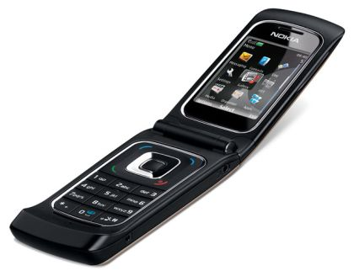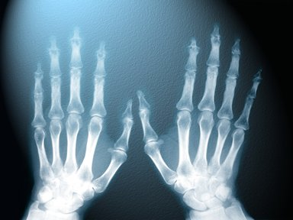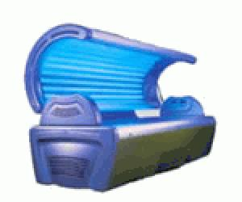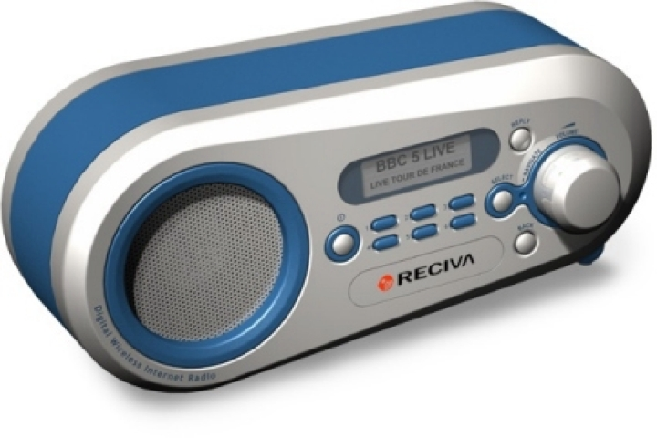
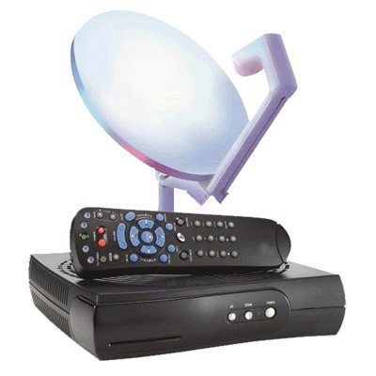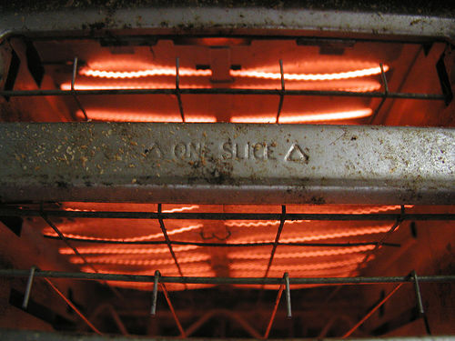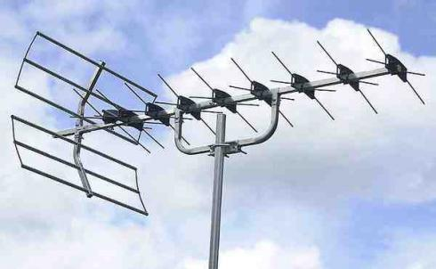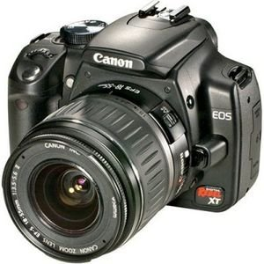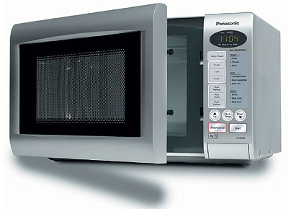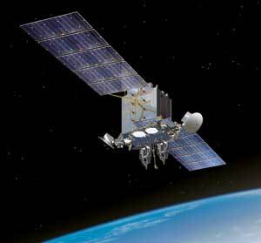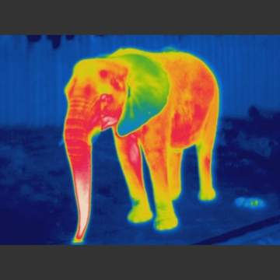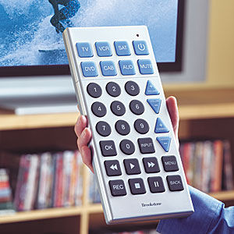

Use the space below to write about the link:

Activity: How can Infra-red Waves be used for Cooking?
Look at the images below. Why is the colour important?
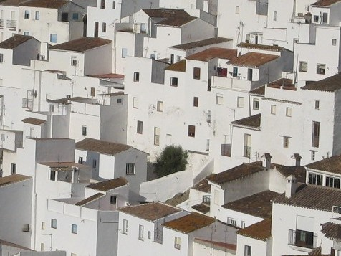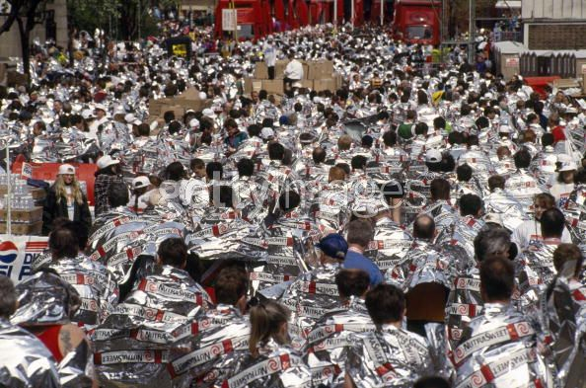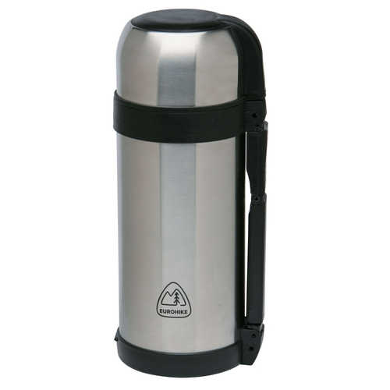
Do an investigation into heating and/or cooling of objects with different coloured surfaces. What rules can you come up with? Write a conclusion below.
Emitters of heat:
Best |  | Worst
Absorbers of heat:
Best |  | Worst
How do infra-red waves cook food?
Check your learning:
Grade G-E | Recognise that warm objects emit radiation from the surface.
Grade G-E | Recognise that infra-red radiation is absorbed by the surface of an object.
Grade D-C | Describe that infrared radiation heats the surface of food and is reflected by shiny surfaces.

Activity: How can microwaves be used for cooking?

Which transfers less energy microwaves or infrared waves? Why is there a difference?

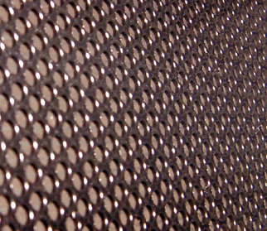 | This is an image of a microwave door. Why is it made of metal with tiny little holes?
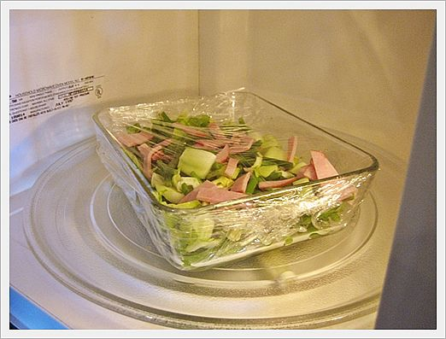 | What material is a microwavable dish usually made from and why?
How does the energy in a microwave cook food?
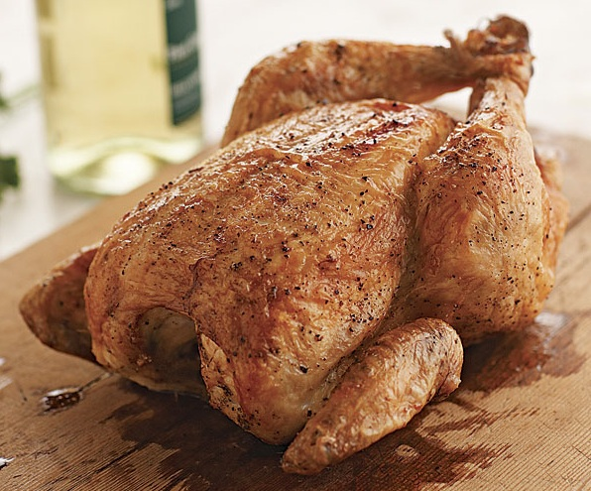

Check your learning:
Grade D-C | Describe the properties of microwaves
Grade B-A* | Describe how the energy associated with microwaves and infrared depend on their frequency.
Grade B-A* | Explain how microwaves and infrared transfer energy to materials

Activity: Past Exam Question
Mark sets up an experiment to investigate the heat loss from containers covered with different materials.


100

90

80
temperature/ ⁰C
B
70

60

50
A
40

30
C
20

10

0
10
20
30
0
time/min

The graph shows cooling curves for 3 containers. A is a pyrex beaker; B is a pyrex beaker covered with aluminium foil; C is a pyrex beaker painted black. Each beaker has a lid.

(a) (i) After what time is the temperature 80ºC for each beaker?

A: ................................ B: ................................ C: ................................[3]
(ii) What is the temperature of each beaker after 10 minutes?

A: ............................... B: ............................... C: ................................[3]

(b)(i) Which beaker is the best emitter of heat? (1 mark, 1 line)

[1]

(ii) How is the heat being lost? (1 mark, 1 line)

[1]

(iii) Name two other ways that heat can be lost when a body is hotter than its surroundings. (2 marks, 2 lines)

[2]
Activity: Cloze Procedure Summary

Use the words below to complete the cloze activity. Each word may be used once.

Black | absorb | more | 1cm
reflected | infrared | conduction | convection
surface | plastic | warm | water
Infrared Radiation
All hot and ................................._{1.} objects emit infrared radiation. The hotter the object the more ................................._{2.} radiation it gives out.
Dull black objects give out ................................._{3.} infrared radiation than shiny bright objects at the same temperature.
Infrared radiation is absorbed by the................................._{4.} of any object. The object warms up. ................................._{5.} surfaces are the best at absorbing infrared radiation.
Infrared heats up the surface of food. The particles on the surface of the food ................................._{6.} the heat energy, and transfer the heat into the food by ................................._{7.}.
Microwave Radiation
Microwaves are also used for heating food. Microwaves in a microwave oven are absorbed by fat and ................................._{8.} molecules.
Microwaves are absorbed ................................._{9.} into food. The energy is transferred to the rest of the food by conduction and ................................._{10.}.
Microwaves pass through glass and ................................._{11.}, but are ................................._{12.} by metals.

Activity: Cross Word Puzzle

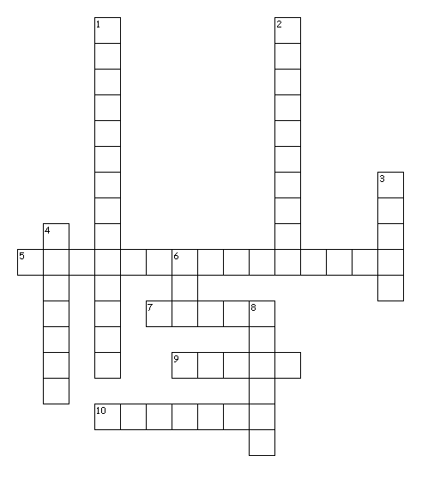
Clues

Across
5. What is the name of the spectrum of waves that infrared and microwaves belong to?
7. Type of material that reflects microwaves.
9. What word describes a surface that is a good reflector of infrared radiation?
10. Which part of the food absorbs infrared radiation?
Down
1. The part of the food that microwaves heat up.
2. The method of heat transfer that transfer the energy into the food.
3. What colour of objects emit more heat?
4. Type of material that microwaves can pass through.
6. How many centimeters do microwaves penetrate into food?
8. Which type of wavelength transfers less energy, longer or shorter?

